Step 1: Go to this [link](https://business-api.tiktok.com/portal)

Step 2: Click Login Button

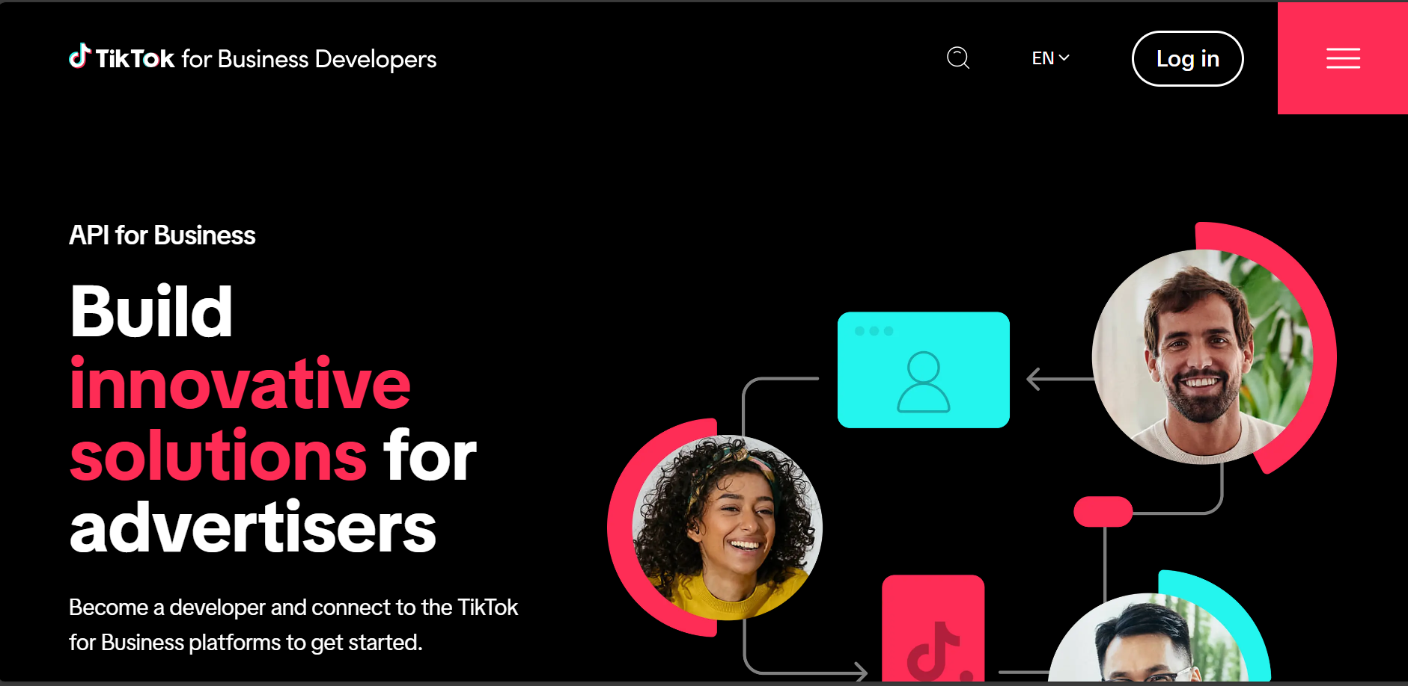

Step 3: Click Login with TikTok

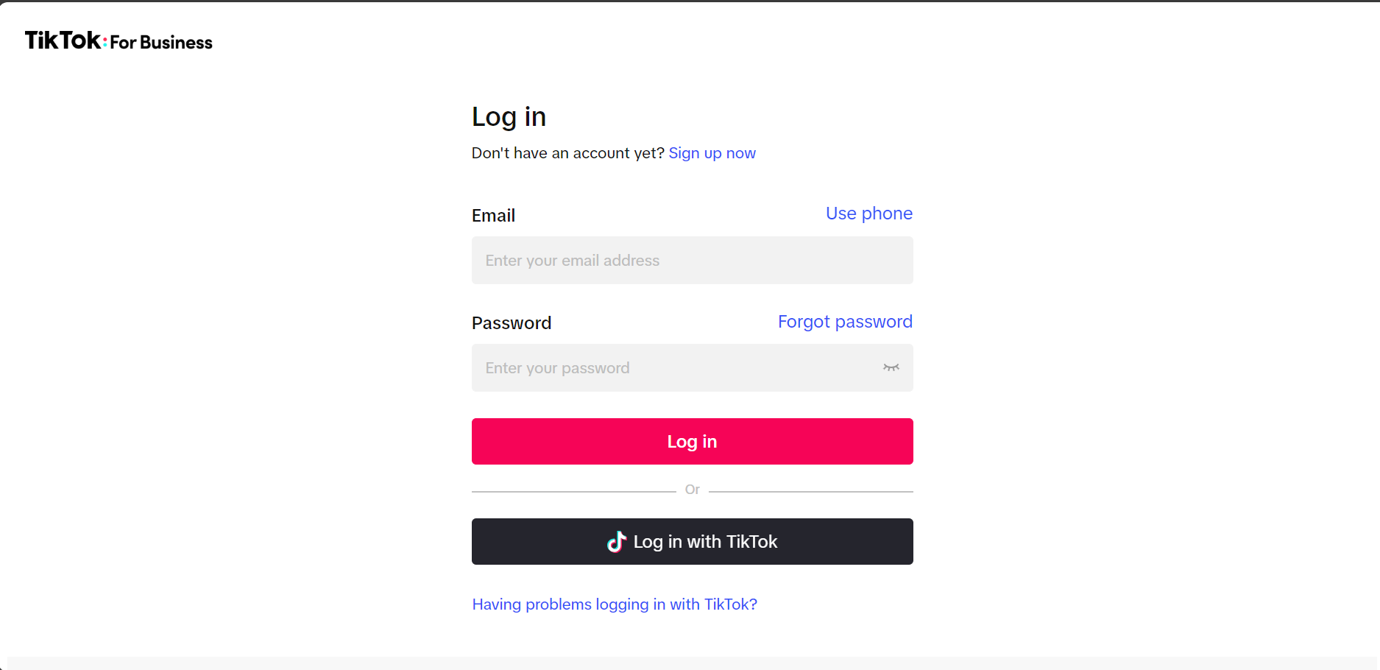

Step 4: Login to your account

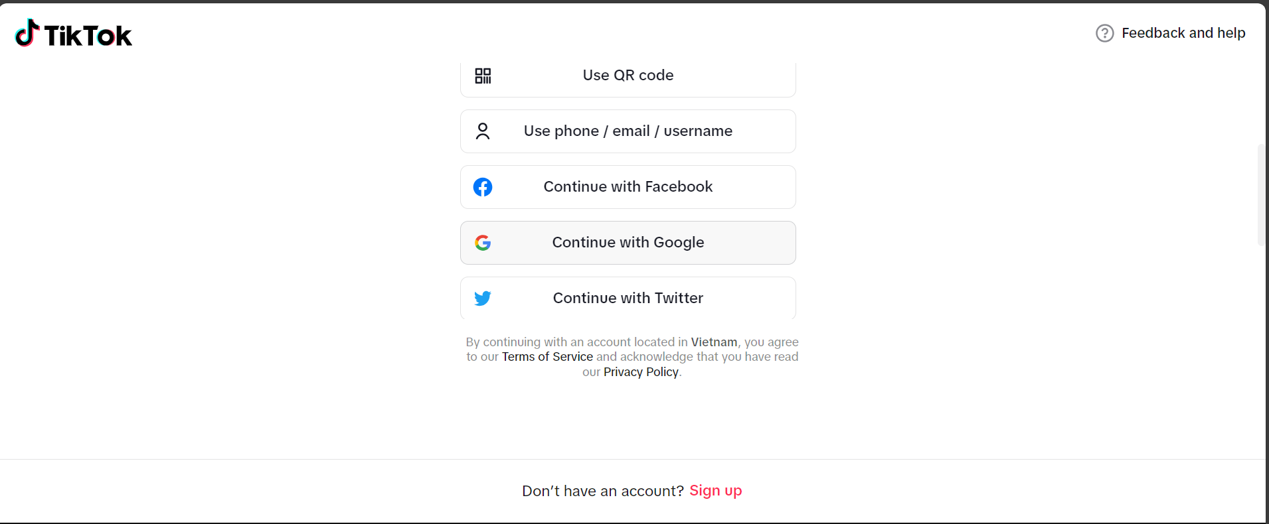

Step 5: Update Your information and create app successfully

Step 6: Click My App after it is created successfully

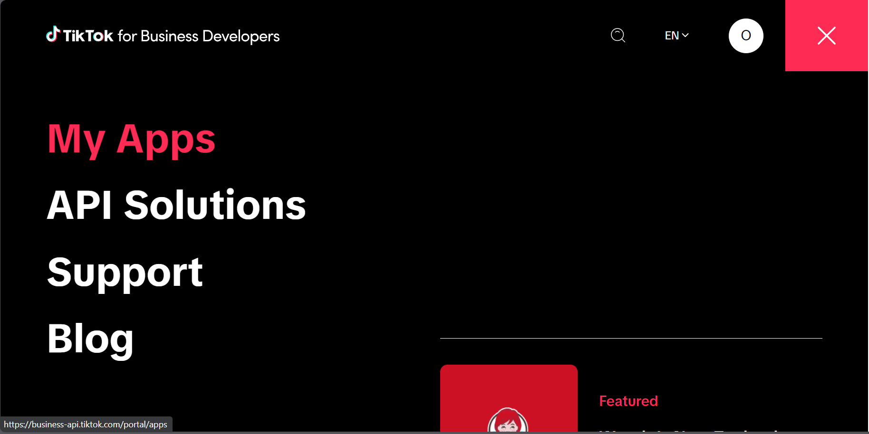

Step 7: Click Paloceras

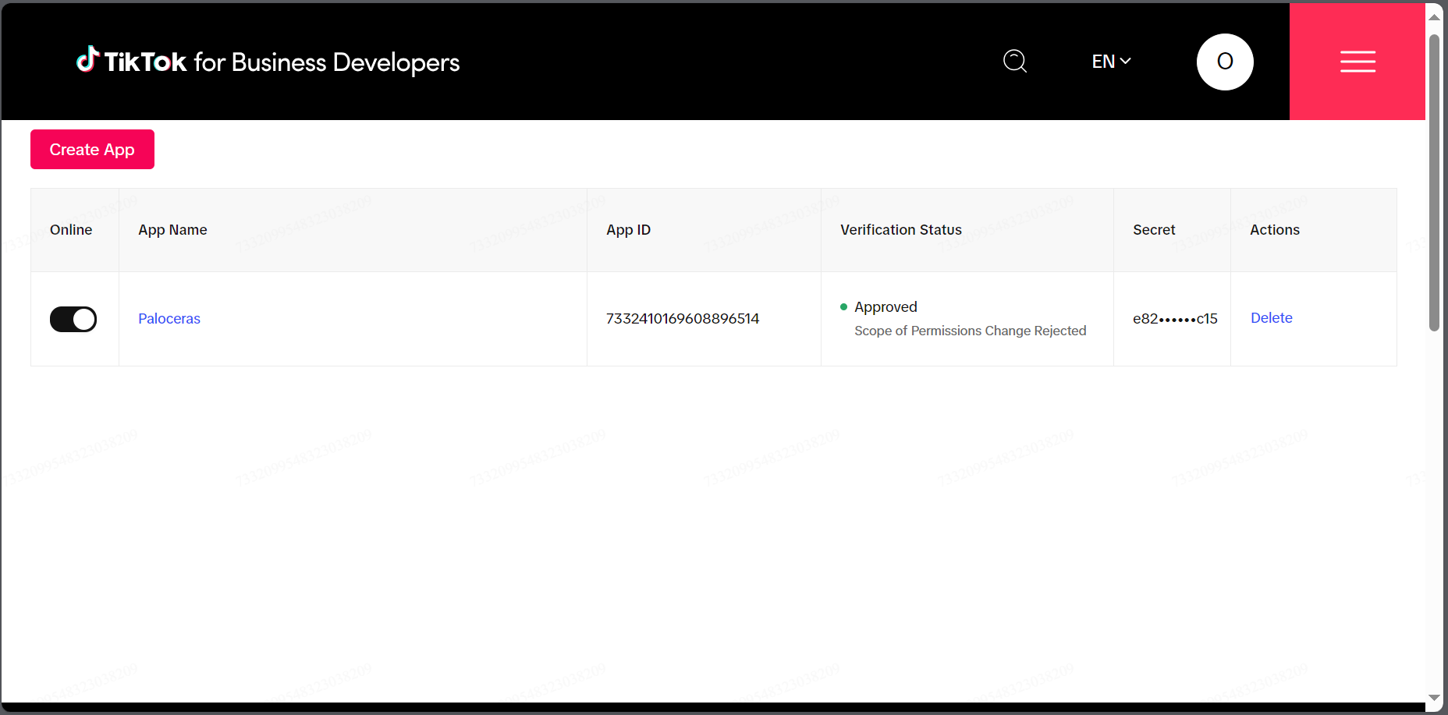

Step 8: Copy the link inside Advertiser authorization URL

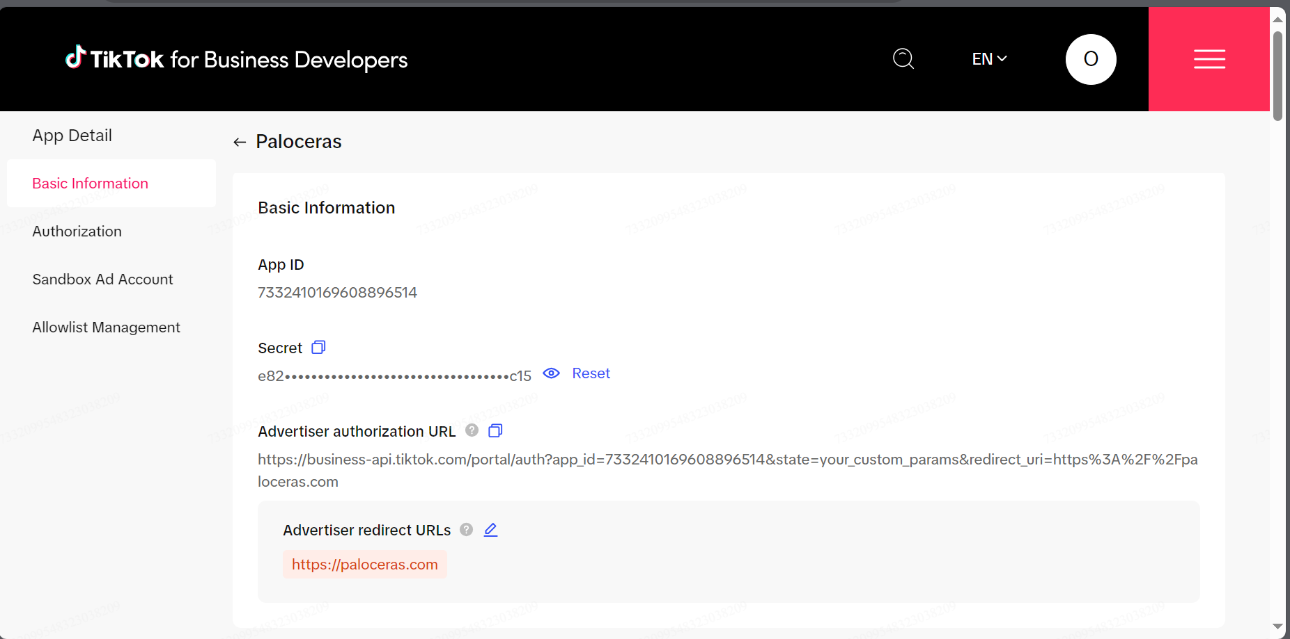

Step 9: Access to the Advertiser authorization URL and click to Confirm button

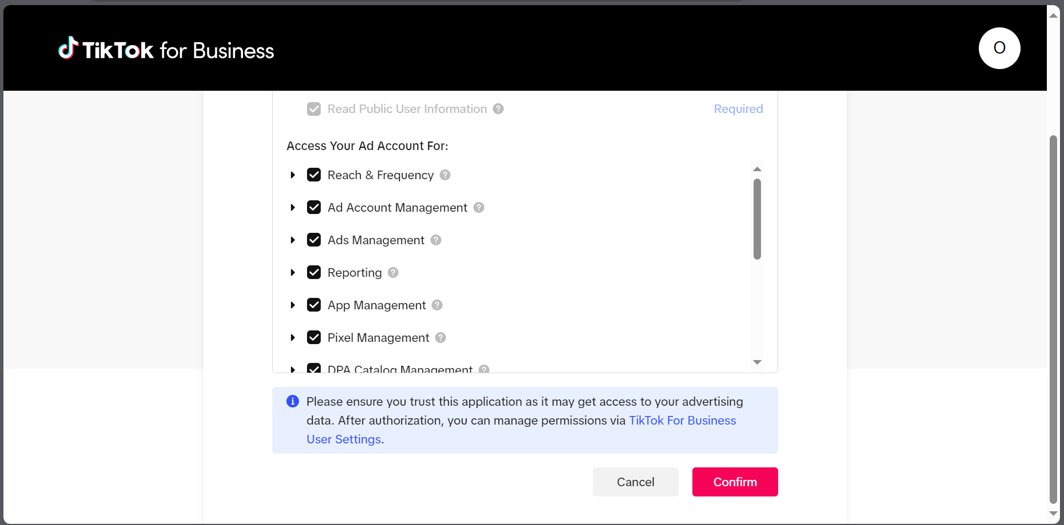

Step 10: Copy the auth_code

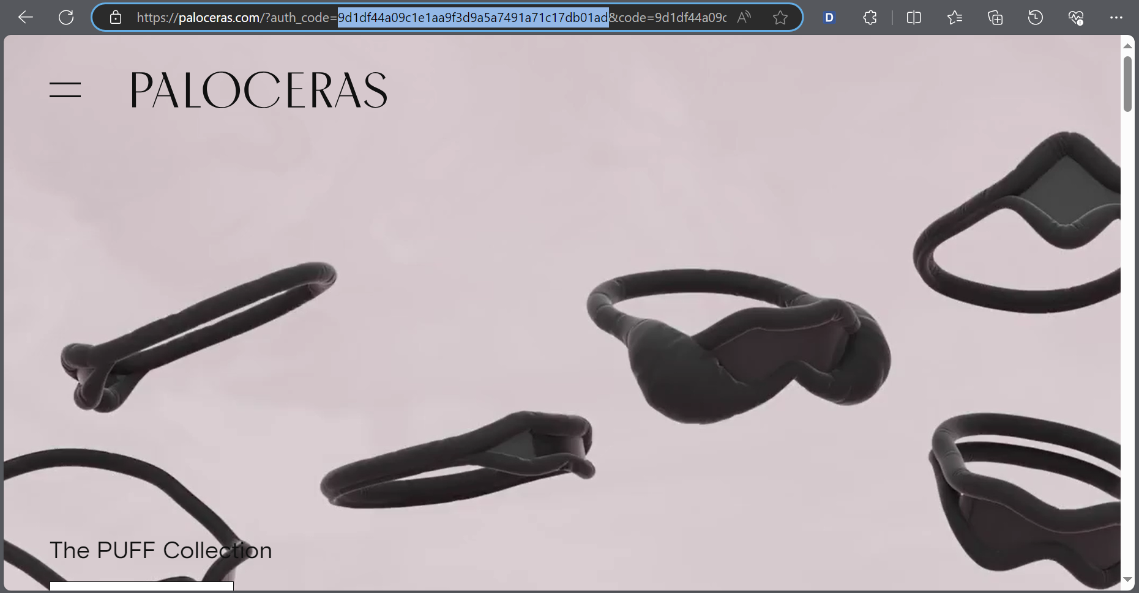

Step 11: Open Postman or Insomnia and type auth_code’s value inside auth_code field:

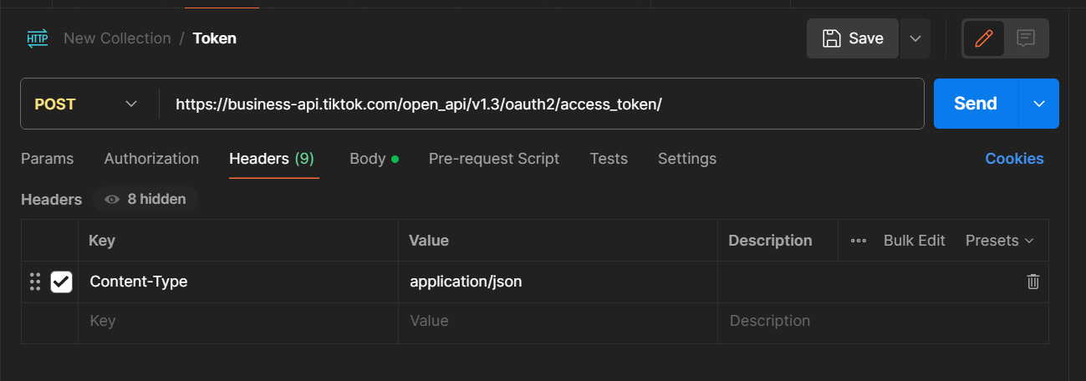

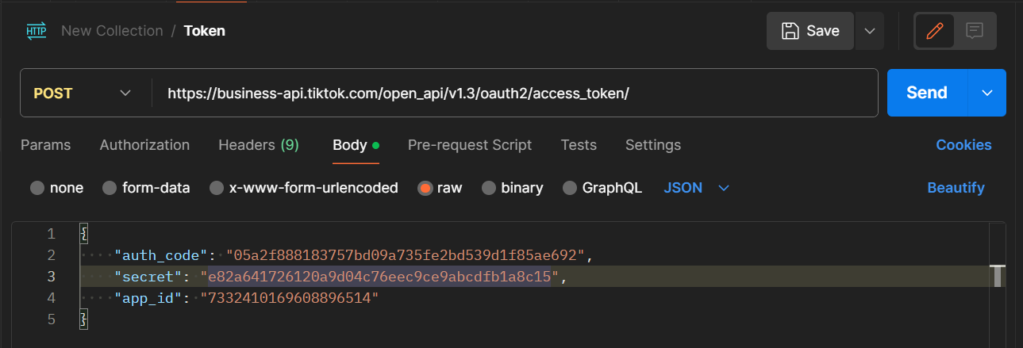

URL: <https://business-api.tiktok.com/open_api/v1.3/oauth2/access_token/>

Secret and App ID is here:

